NYSADSP 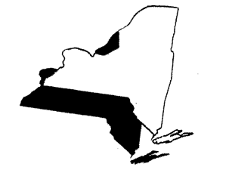

Dear Day and Employment Service Provider:

The Vision of the New York State Association of Day Service Providers is to help provider members develop quality community-based vocational, volunteer, educational and social activities that maximizes each participant’s personal growth and enriches their life experience. This is achieved through inter-agency collaboration, advocacy, training, and innovation.

Benefits of membership include:
- Eligible for Innovation Grants – six grants totaling over $5000.00.
- Monthly remote meetings/trainings – free of charge to NYSADSP member agencies.
- Discounted rates to regional events and mini-conferences – and the discount applies to all members of your agency.
- Annual Leadership and DSP awards in each of the 6 NYS Regions.
- Annual Symposium – this conference focuses on DSP’s and front-line supervisors and features State-wide best practices, grant presentations, OPWDD updates and networking opportunities.
- Access to Board members for technical, programmatic, and regulatory concerns.
- Information networking to approximately 100 agencies across NYS.
- NYSADSP provides direct feedback to OPWDD representing our membership and challenges they are facing.

It only makes sense

NYSADSP offers a cost-effective membership!

Membership – $375.00, which includes a provider member and unlimited associate members. This makes the entire agency eligible for all noted benefits.

I look forward to collaborating with you and your agency to promote a service environment that offers personal growth and development for people with developmental disabilities to live to their fullest potential.

To become a member of the NYSADSP, please fill out the enclosed application and mail along with your membership dues to:

NYSADSP c/o Christina Abbinanti New York State Association of Day Service Providers
1820 Lemoyne Ave
Syracuse, NY 13208

For additional information email Christina Abbinanti at CAbbinanti@lifesworc.org

If you are not yet a member but would like to attend a meeting in your region, please contact Christina Abbinanti at the email above.

Sincerely,

Bruce Drake, President
New York State Association of Day Service Providers

